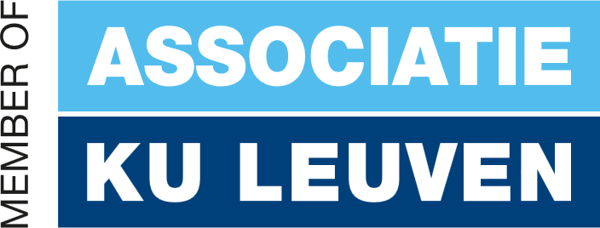

Concept Phase Report
Team benchmark 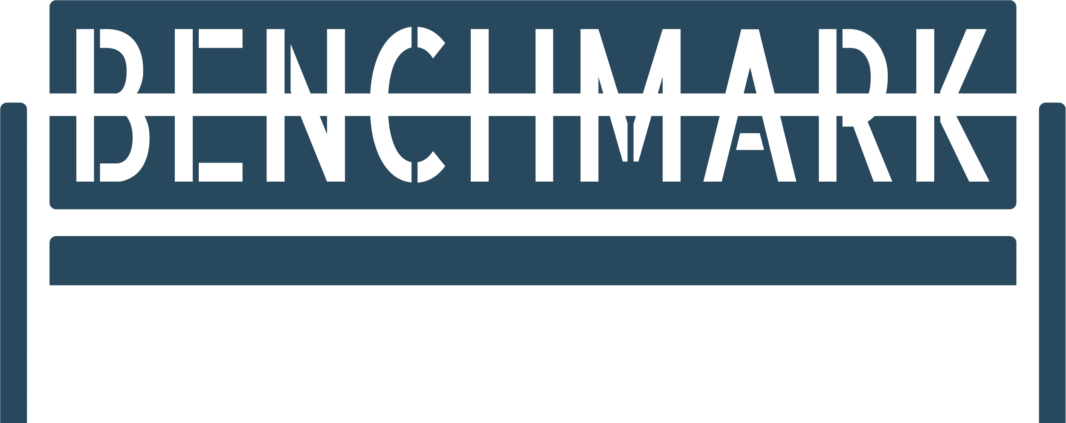

Lorenzo miechielsen, Maarten Marx, egemen Alkan, filip kolb, Mark vaikul

Academic Year 2024-2025
Campus Thomas more, Kleinhoefstraat 4, 2440 Geel

Table of Contents
2
Table of Contents 4
Introduction 5
1 Project Team 6
2 Timeline 7
3 Risks 8
3.1 Possible solutions 8
4 Research 8
4.1 Frontend solution 9
4.1.1 Research 9
4.1.2 SME Talk 10
4.1.3 Designs 10
4.1.4 Conclusion 13
4.2 Backend solutions 14
4.2.1 Research 14
4.2.2 SME Talk 15
4.2.3 Conclusion 15
4.3 AI solutions 16
4.3.1 Research 16
4.3.2 SME Talk 20
4.3.3 Conclusion 21
4.4 Cloud solution 24
4.4.1 Research 24
4.4.2 SME Talk 26
4.4.3 Conclusion 27
4.5 Hardware solutions 28
4.5.1 Research 28
4.5.2 SME Talk 29
4.5.3 Conclusion 29
Final conclusion…. 30

Introduction
The contents of this document will outline our research on creating an AI-powered bench that engages users in interactive conversations. The goal is to integrate advanced technologies like AI-driven speech-to-text (STT) and text-to-speech (TTS) systems, robust backend and frontend frameworks, and scalable cloud solutions, ensuring an inclusive and privacy-compliant design.
This report outlines the findings and decisions made during the research phase, which sets the foundation for the realization phase. We will go over our considerations that lead us to our decisions, advice provided by Subject Matter Experts (SMEs), risks and possible solutions, and more.

Our Team
We are team Benchmark. Our team contains 5 third year students, each with their own speciality.
Our team lead and document lead, Maarten Marx and Lorenzo Miechielsen, both specialize in application development.
The rest of the team consists of Egemen Alkan and Mark Vaikul, who both specialize in AI technologies, and Filip Kolb, who is well-versed in the realm of Cloud and Cyber Security.
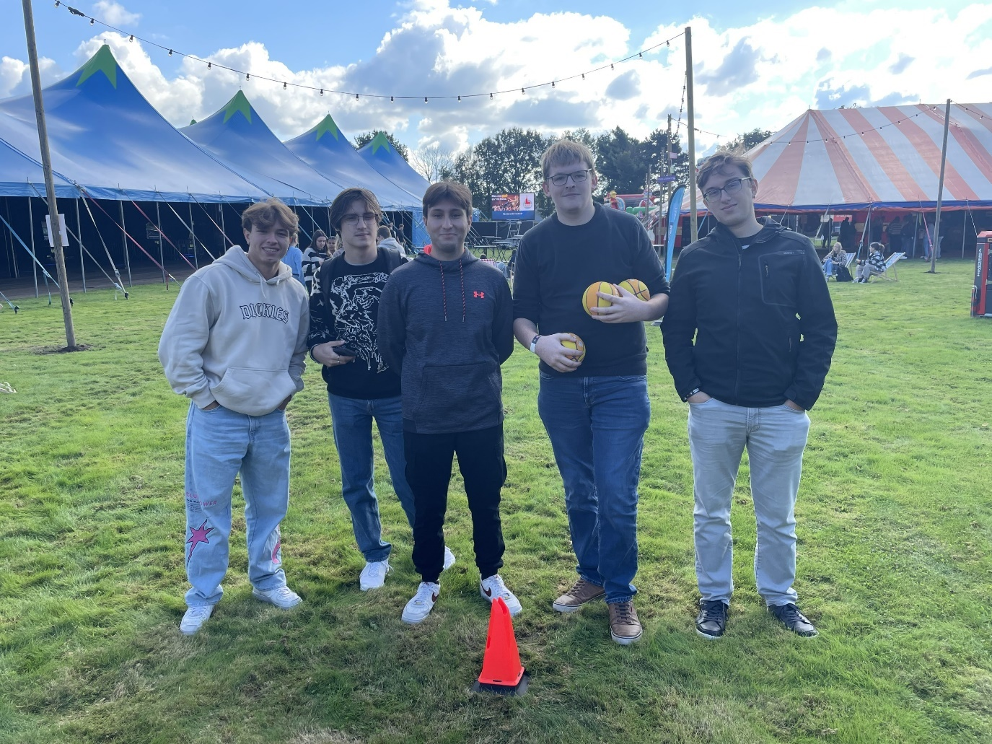

Timeline
A few months ago, we finished the ideation phase. The team leads of the three separate groups got together with Rurant to get feedback on their research. After this meeting, we were able to start working on the concept phase.
During this phase, we researched specific technologies, testing and comparing each of them to find the best fit for our project. We also made designs and diagrams to create a clearly defined structure for our project.
Based on this document, and the feedback provided on it, we will realise this project during the realization phase.

Risks

After much consideration, we’ve concluded that there are three main risk that go paired with this project.

The first risk is privacy. We need to ask the users for permission to store the data we collect, and share it with the interested parties.


Another risk to take into consideration is cost. Cloud costs can ramp up rapidly. The same goes for energy costs and some other hidden costs.

The last risk is Integrity. The bench would stop working in the event of a power outage. It could also be subject to vandalism.

Possible solutions
To ensure privacy, we will make all answers anonymous, so the users won’t need to provide any personal information, unless they choose to do so. We will also always inform users of where the data will go, and what it will be used for. We also need to ensure that all data is secured, so that no bad actors will be able to access it.
We’ve been looking for cloud and hardware solutions that are available for a reasonable price, in order to cut costs while maintaining effectiveness. We will also be setting limits on the usage of could resources to mitigate unexpected expenses.
Risks involving integrity are mostly a result of factors that are out of our control. While the students of construction who we’ll work with to build the bench can do their best to make it as strong as possible, we can never full ensure that it will be able to withstand all forms of vandalism.

Research
In this part of our report, we would like to go over the research we did on each part of the project. You will also be able to read about the SME meeting we had and, you will be able to look at some tests we did in preparation for the realization phase.

Frontend Solution
In this part, we will talk about which frontend solutions we researched, what the result of our research is, and the mock-ups and tests we made.

Research
We researched multiple options for our frontend technology. We narrowed the options down to two solutions: Angular and React. Part of the reason is that these are two of the programming languages we’ve learned about in the past three years. Both have their advantages and disadvantages.
Let’s start with React. It’s a very flexible framework, which supports a large variety of additional library. These libraries handle processes like routing, state management and form handling. Performance is also one of the big advantages of React. Its virtual DOM optimizes rendering which is particularly beneficial for data-heavy dashboards with frequent updates. React uses reusable components, making it easy to manage and scale a dashboard application.
Disadvantages of using React include that it needs more setup for state management, routing and API handling compared to Angular’s built-in tools. React can also have a steep learning curve for newcomers, while it offers flexibility, newcomers may struggle with deciding which libraries to use or how to design the application. Another disadvantage is the lack of conventions that could lead to inconsistent codebases if not managed properly.
Unlike React, Angular provides a complete solution out of the box, including routing, state management, and form handling, which is ideal for structured and feature-rich dashboards with well-defined requirements. Angular simplifies data synchronization between the model and view, reducing boilerplate code for interactive dashboards. Angular’s built-in dependency injection simplifies service management, making it easier to build complex dashboards. Angular promotes splitting code into modules for better organization, especially beneficial for large-scale dashboard projects. Angular is also built with TypeScript, which enforces strict typing and helps prevent runtime errors, especially in complex dashboard logic.
The disadvantages of using Angular are that is has a more complex structure and requires knowledge of TypeScript, RxJS and Angular-specific concepts like decorators and modules. Angular applications can be larger compared to React apps, which might be a concern for dashboards with tight performance requirements. While Angular provides a lot out of the box, it’s less flexible than React when integrating third-party libraries or custom solutions. Last but not least, development in Angular often requires more boilerplate and configuration compared to React.

SME Talk
Lorenzo and Maarten had a meeting with one of the SMEs on Application Development. During this meeting, we and the other groups discussed both frontend and backend solutions. All groups had mostly the same frontend frameworks in mind; React and Angular. For the backend, most groups also chose to use C#. Our SME suggested to use the same language for both frontend and backend, to minimize the use of multiple languages in the same project.
We also discussed whether or not it was our responsibility to write the code on the microcontroller. He told us it was up to us, but in the end, it will be us that writes the code, for which we will use Python. This is one of the reasons he told us to use the same language for the frontend and backend.

Designs
We’ve made a few designs for different pages of the dashboard. We will list them below and describe them in short.
Home Page
On this page you will be able to see the different locations in the system. For each location, it shows some useful information, like the number of responses and the overall sentiment. You’ll also be able to add a new location for a bench.

Benches Page
On this page you see the different benches in the system. Each bench has a name, location and status. You can also add a new bench.
Analytics Page
This page is used to show certain analytics that the benches have collected. The statistics that are shown are likely to change depending on feedback, and the data available to us.
Location Management Page
On this page, you can configure a location. You can provide a context to the bench, add or remove questions, and add fillers for the bench to fill empty space with. There’s also a convenient link to view any conversations the bench on this location has had.
Overview Conversation Page
This page allows you to view any past conversations in a familiar format. Each conversation also includes a sentiment – positive or negative – derived from it.
Bench Management Page
This page will allow you to make changes to a bench. You can change its name, location, voice and activate or deactivate this specific bench.

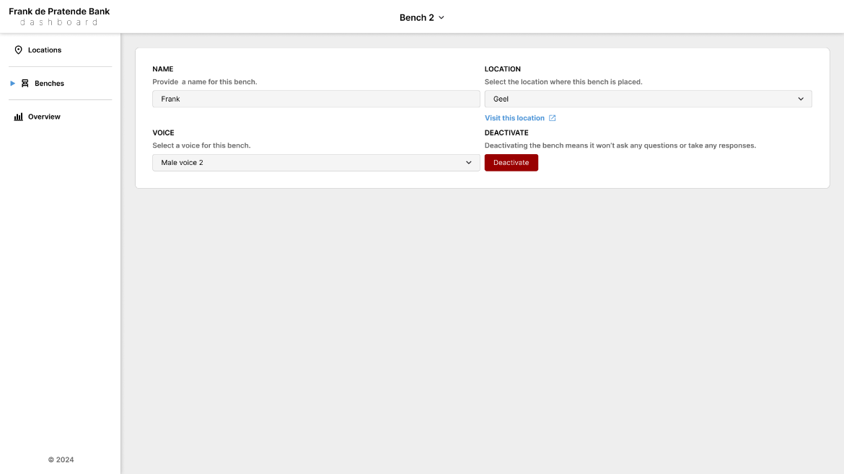

Conclusion
The frontend technology we decided on is Angular. Comparing the advantages and disadvantages we mentioned at the research part, Angular fits better towards the project requirements.

Backend Solutions
Next, we will discuss which backend solutions we researched, what the result of our research is, and the mock-ups and tests we made.

Research
It didn’t take much consideration for us to determine that we’d choose C# with ASP.NET as our backend technology, as this is a language that we are familiar with from classes during earlier years. Still, we researched the advantages and disadvantages of using C#.
ASP.NET Core provides a full-featured framework for building RESTful APIs, including built-in support for routing, model binding, validation and dependency injection. It supports both REST and GraphQL APIs. Strongly typed models ensure reliability in API design and tools like Swagger/OpenAPI integration make documenting and testing APIs straightforward. ASP.NET Core is highly optimized for performance, making it suitable for high-throughput APIs. Built-in features like middleware for cashing, authentication and logging enhance API performance and maintainability. C# has native support for asynchronous programming with async/await improves the scalability of API services. C# has seamless integration with ORM tools like Entity Framework Core simplifies database operations and modern .NET is cross-platform, allowing deployment on Windows, Linux or Docker.
For smaller projects, ASP.NET Core might feel over-engineered compared to lighter alternatives like Node.js or Flask. On top of that, some legacy features in .NET might still favor Windows environments, although this has improved significantly in recent years.

SME Talk
As mentioned in the previous section, our SME recommended us to use as much of the same languages where possible. While we did briefly consider using TypeScript, we determined that each language has its own benefits in different areas, and a language like C# would be more fitting.

Conclusion
We choose to go for C#. The biggest disadvantage that comes with this decision is that we will be working with multiple programming languages. However, these are all languages that we have past experience with, so we were willing to take that risk.

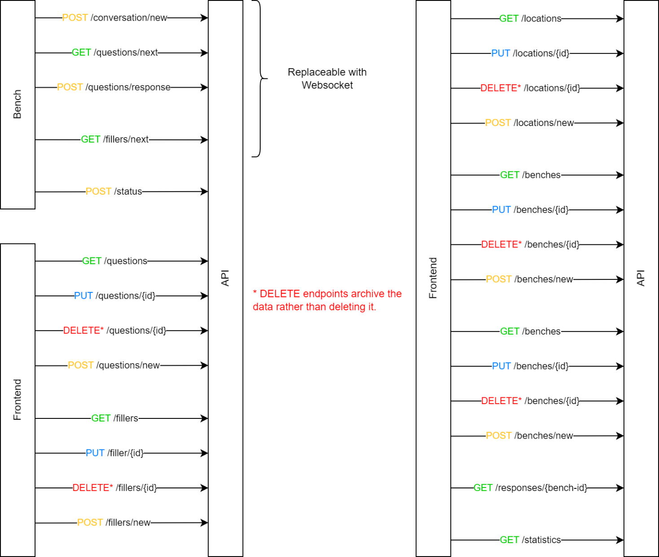

AI solutions
In this section, we’ll go over which AI solutions we considered, what the result of our research is, and the reasons for our decisions.

Research
As AI is the core of this project, we carefully considered many different options to find the optimal AI models for each task.
Research on Closed-Source Speech-to-Text Models for the Dutch Language
The first option we considered is Whisper by OpenAI. This is a speech-to-text model that is highly reliable, accurate, and is capable of handling the nuances of the Dutch language effectively. It can handle noisy environments and works for real-time and batch processing. If we want to integrate this model, we need to evaluate if its suitable for cloud hosting or hybrid setups (on-device and cloud), and we need to test latency when deployed as part of CrewAI’s STT agent.
Next, we researched OpenAI’s Speech-to-Speech API. It converts spoken input to another spoken language in real-time. It includes robust STT capabilities to multiple languages, including Dutch. If we want to integrate this, we need to test the latency and responsiveness for real time conversational use and we need to evaluate if the speech-to-speech API can simplify the workflow by combining STT and TTS.
We also researched Microsoft Azure Cognitive Services. This is a speech-to-text model that supports the Dutch language with built-in noise suppression. It has real-time and batch transcription available and is customizable for specific vocabulary and dialects. For the integration we need to test Azure’s STT integration with CrewAI’s STT agent. We also need to evaluate the performance for noisy outdoor settings with Groq-enhanced pipelines
Next, we researched Amazon Transcribe. It is a speech-to-text model that has Real-time transcription with the Dutch language supported. It also includes speaker diarization and a custom vocabulary. For the integration we need to explore using Amazon Transcribe for hybrid cloud deployments and test latency for real-time transcription tasks.
Lastly, we researched Soniox, another speech-to-text model. This model has a high-accuracy transcription for the Dutch language and offers speaker separation and advanced noise handling. If we want to integrate this model, we need to test the suitability for noisy environments and the integration with CrewAI.

Research on Closed-Source Text-to-Speech Models for Dutch

Whisper by OpenAI can also serve as a text-to-speech model. This is the first option we researched. To integrate it, we need to explore how to configure TTS capabilities for neural voice generation and test Whisper’s performance in generating Dutch speech locally or via API.

We considered OpenAI’s Speech-to-Speech API here as well. It is a real-time TTS model integrated with STT, able to convert processed text directly into spoken output in real-time. The model also includes high-quality TTS in the Dutch language. For its integration, we need to test the suitability for generating conversational TTS responses.

Next, we researched Microsoft Azure Cognitive Services. This is a text-to-speech model that supports neural voices with natural intonation and the Dutch language. It has customizable voice options for unique user experiences. If we want to integrate this model, we need to evaluate it for real-time TTS tasks in CrewAI’s TTS agent and test the performance for Groq-enhanced local synthesis.

We also researched Amazon Polly, a text-to-speech model that supports the Dutch language with multiple voice options. It has neural voices available for more natural speech output and a low-latency real-time synthesis. For the integration, we need to explore the suitability fallback scenarios in CrewAI.

Lastly, we researched Acapella, a text-to-speech model with high-quality, customizable voices in Dutch. It includes emotion-based intonation for more expressive speech. For its integration, we need to test integration for conversational TTS responses.

Noise Reduction Techniques

For noise reduction, we researched 2 possible techniques. First, Groq API in combination with Whisper noise handling. We need to investigate Whisper’s built-in noise-handling capabilities for the Dutch language in noisy environments, and we need to explore pairing Groq-enhanced noise reduction pipelines with Whisper STT.

Secondly, we researched OpenAI speech-to-speech API. We need to research its effectiveness in handling noisy inputs without pre-processing and evaluate real-time noise suppression quality.

Research on Models for Intent Classification in Dutch

We researched cloud-hosted options, particularly BERTje and mBERT. First, we took a look at BERTje. We would need to fine-tune it for intent detection and explore it using Qdrant or Pinecone for vector storage and retrieval of intent embeddings.
BERTje, by University of Groningen
For mBERT, we need to assess performance for the Dutch language and multilingual inputs. We also need to explore latency improvements when hosted on Groq-optimized cloud setups.

Investigation on Emotion Detection Models/Tools for Dutch Inputs

In this part we did research on GoEmotions and SentiStrength. With GoEmotions we need to fine-tune it for the Dutch language emotion classification as well as use Qdrant/Pinecone for embedding-based emotion retrieval.

For SentiStrength, we need to pair lightweight emotion scoring with Groq acceleration for real-time performance.

Defining a Text Preprocessing Pipeline

We researched preprocessing in a pipeline. We looked at tokenization, lemmatization and stop-word removal using spaCy or Frog NLP Toolkit. We need to integrate preprocessing into the pipeline for the Dutch language STT outputs before passing them to NLP agents.

Evaluating Models/Tools for Response Generation

We researched 2 possible solutions: OpenAi GPT-4 and mBART. OpenAI has a cloud-hosted LLM for generating Dutch responses and is able to store vectorized outputs in Qdrant/Pinecone for retrieval-based conversational memory.

With mBART, we need to fine-tune it for lightweight Dutch response generation and evaluate real-time performance on Groq-enhanced cloud setups.

Investigating Methods for Managing Context in Multi-turn Conversations

We investigated 2 possible solutions, bot CrewAI with a vector database, and Frameworks. CrewAI uses Qdrant or Pinecone to store and retrieve conversational embeddings for context retention.

To use Frameworks, we need to test Rasa or Dialogflow for managing context across CrewAI agents and explore Groq acceleration for context-heavy NLP tasks.

Research on Open-Source STT models for Dutch

We researched Whisper. We need to explore open-source deployment for STT and evaluate Whisper’s integration with Groq for real-time edge deployment.

Research on Open-Source TTS models for Dutch

We investigated the use of Coqui TTS. It is open-source and trainable for the Dutch language. We need to test Groq-enhanced performance for faster synthesis.

Cloud Hosting

We researched 2 possible solutions, OpenAI cloud and Groq-Optimized cloud hosting.

With OpenAI, we have to host Whisper and GPT-4 for high-performance cloud preprocessing. We need to evaluate costs and API limitations.

With Groq, we have the possibilities of Google cloud, Azure and AWS for containerized Groq deployments.

Vector Database Research

We researched 2 possible solutions: Qdrant and Pinecone.

Qdrant is open-source and is optimized for real-time search and retrieval. It has a high compatibility with embedding-based conversational systems. For its implementation, we need to test CrewAI compatibility for context storage and evaluate latency for conversational embeddings.

Pinecone is scalable and has a high-performance vector database as well as a managed service with minimal maintenance. For its integration, we need to test embedding retrieval for conversational AI and compare scalability with Qdrant for real-time workloads.

SME Talk
Egemen and Mark explored the use of CrewAI as a potential framework for managing the AI components of the project. CrewAI's ability to orchestrate multi-agent collaboration was highlighted as a strong candidate for implementing conversational intelligence, particularly for managing tasks like intent detection, response generation, and conversation flow in a modular manner.
Additionally, the conversation addressed the challenges posed by noisy, outdoor environments, particularly in relation to speech recognition accuracy. To mitigate this issue, two potential solutions were proposed:
- A button could be integrated into the bench to trigger the AI system when a user wants to interact. This simple mechanism would reduce unnecessary background noise by only activating the microphone when the user is ready to speak.

- Another innovative suggestion was to incorporate a landline-style handset. Users would lift the phone to start the interaction, which would: physically signal the system that the user is ready to speak, bring the microphone closer to the user, significantly improving audio quality and reducing background noise, and enhance the system's usability in outdoor settings by isolating the user’s voice from ambient noise.
These approaches not only address technical challenges but also offer user-friendly solutions that align with the project's goals of inclusivity and accessibility. Further exploration and testing will help determine which option provides the best balance of practicality and performance.

Conclusion
Based on the research and integration requirements for the project, we identified the following options as the most suitable choices for each component. These recommendations prioritize accuracy, latency, flexibility, and compatibility with the overall architecture involving CrewAI and Groq API.
Speech-to-text
We choose for Whisper by OpenAI. Whisper offers robust transcription accuracy for Dutch even in noisy environments. It supports both on-device and cloud deployment allowing flexibility for edge devices or hybrid setups. Its open-source nature ensures cost-effectiveness for large-scale deployments while maintaining customization potential.
As a backup option, we would have Microsoft Azure Cognitive services. Azures STT model provides high-quality transcription with built-in noise suppression and vocabulary customization. Its best suited for cloud-based fallback in cases where whisper’s performance is limited by hardware constraints.

Text-To-Speech
We choose OpenAI’ speech-to-speech API. It combines real-time STT and TTS in a single workflow, simplifying system complexity. It has a high-quality, natural-sounding Dutch voices that require minimal configuration. Lastly it is best for conversational interactions due to low latency and real-time capabilities.
For backup, we choose Coqui TTS. It is open-source and trainable for custom Dutch voices making it ideal for on-device deployment with Groq’s performance optimization. It also offers flexibility for creating a unique voice for the bench without relying in external services.
Noise Reduction
We choose RNNoise with Groq API for noise reduction. We made this decision because RNNoise real-time suppression capabilities can be optimized in Groq for fast and efficient pre-processing before STT. It’s also suitable for outdoor environments where ambient noise is a concern.
As a backup, we choose OpenAI speech-to-speech API. It has built-in noise handling that minimizes the need for additional pre-processing and it simplifies deployment.
Intent Classification
We choose BERTje for Intent Classification. It is pre-trained specifically for Dutch ensuring high accuracy for intent detection tasks. It is also fine-tuneable to support project-specific intents such as feedback collection and conversational flow
We choose mBERT as a backup. This because its multilingual capabilities make it more generalizable for future expansions or use it with Flemish dialects. It’s also less resource-intensive for cloud-hosted workflows.
Emotion Detection
We choose GoEmotions. It has multi-label emotion detection and covers a broad range of emotional states, enhancing it conversational depth. It’s fine-tuneable for Dutch to align with the project’s linguistic needs.
Our backup option is SentiStrength. It is lightweight and fast for real-time emotion scoring and is suitable for edge devices.
Vector Database
We choose Qdrant. It is open-source and highly optimized for real-time embedding storage and retrieval. It easily integrates with CrewAI for conversational memory management and context retention.
Our backup is Pinecone. It is a managed service with scalable performance, ideal for handling larger workloads in cloud-hosted systems. It needs minimal maintenance and reduces operational overhead.

Overall Architecture Considerations
- Cloud-hosted components
  - Whisper (as a fallback), BERTje, GoEmotions, and GPT-4 will be hosted in the cloud for scalable inference.
  - Qdrant will manage vectorized embeddings for context and memory.
- On-device components
  - Whisper (on-device configuration) for real-time STT, supported by Groq-accelerated RNNoise for noise reduction.
  - Coqui TTS or OpenAI Speech-to-Speech API for real-time TTS.
- CrewAI integration
  - Modular agents will orchestrate tasks between cloud and edge devices, ensuring seamless interaction and minimal latency.
Final Recommendation
The combination of Whisper (STT), OpenAI Speech-to-Speech API (TTS), BERTje (Intent Classification), and Qdrant (Vector Database) offers the best balance of performance, cost-effectiveness, and scalability for the Talking Bench AI Project. These tools align well with the architecture's modular design and Groq API's optimization capabilities.

Cloud solution
In this section, we are going to talk about which cloud solutions we researched, what the result of our research is and the and tests we did.

Research
We researched a couple solutions possible for our project.
Voice Data Transporter to Container in Cloud
The container set up in the Cloud will expect voice data from the bank with the aim of converting the voice data to text. This requires several steps that we will need to move from the local data to the Cloud and be able to use it.
First and foremost, we need an API that will handle sending the audio. We can use an HTTP client to send. For this we use the requests library or httpx, both are possible.
Next, we provide a cloud environment with a container. Where network access is configured in the form of firewall rules and security policies.
Finally, we use HTTPS to secure data transfer. Add authentication to the API, such as tokens or API keys, to restrict access.
MongoDB
MongoDB is a good choice for storing transcripts and associated metadata in a speech-to-text application. Thanks to its flexible schema, MongoDB is good for storing dynamic data such as transcripts, timestamps, speaker information, and location. We can easily store various metadata without defining a strict structure in advance. MongoDB can also store and process large amounts of data efficiently, making it suitable for growing applications.

MongoDB vs. PostgreSQL
Let’s go over the difference between MongoDB and PostgreSQL, another database we did a bit of research on we will place it in a diagram for a more clear view.

Feature | MongoDB | PostgreSQL
Schematic-flexibility | No predefined schedule; dynamically expandable. | Requires a predefined schedule.
Suitability for JSON-data | Natural storage of JSON documents. | Supports JSON, but less intuitive.
Relations between data | Limited support, focused on non-relational data. | Very suitable for relational data.
Complexity of queries | Simple for document-based searches. | Suitable for complex relational queries.
Scalability | Horizontally scalable, ideal for large data sets. | More focused on vertical scalability.

Cost analysis
The estimated monthly cost on a pay as you go basis will look something like the screenshots here and will be around € 195,83. This is subject to change tough because of changes that might occur during the project and the cost may increase or decrease depending on the requirements.

SME Talk
Cloud
During the meeting, Filip mentioned that the cloud will mainly be used for the initial training of the model. Training on a powerful server, such as in Azure, gives us the opportunity to develop a complex and accurate model. This model can then be distributed to the hardware for local use.
Azure was mentioned as a possible choice because of the possibility that the platform is already in use at our customer. This could provide better integration with existing systems. However, we still need to verify this with Rurant to better understand their preferences and infrastructure.
A major point of discussion was minimizing data traffic to the cloud. By processing as much as possible locally, only necessary information is sent, which further strengthens GDPR compliance. This is crucial to ensure that no sensitive or personal data is unintentionally stored or shared.
We also discussed that we need to be transparent about the language choices we make. It is important to document not only why certain languages ​​are chosen, but also why others are not suitable. Furthermore, we discussed how to implement the AAA triad (Authentication, Authorization, Accountability) in our logic to ensure security and traceability.
Finally, it was discussed that we always use ORM (Object-Relational Mapping) to ensure secure interactions with databases. It was emphasized that avoiding manual SQL statements is essential to prevent risks such as SQL injections.
Software oriented
During the meeting, we also discussed the approach to software development and quality assurance within the project.
It was agreed that all changes to the code would be implemented via pull requests and that these would be reviewed by at least four eyes. This helps to prevent errors and vulnerabilities in the code. In addition, we discussed how we could implement a clear branch strategy. Possible options are branches per ticket, per milestone, per feature, or even per person. It is important to maintain consistency in this.
It was also agreed that unit tests should be performed with every merge request. This helps to ensure the stability and functionality of the code with every change.
An important point that came up was implementing a security strategy. It was discussed that we will use SAST (Static Application Security Testing) and DAST (Dynamic Application Security Testing) before code is pushed to production. This dual process is intended to detect and resolve both static and dynamic vulnerabilities at an early stage.
Finally, the importance of documentation was discussed. We will be creating WRMs (Work Requirements and Manuals) throughout the project to ensure clear documentation of requirements, processes and deliverables. This is essential for internal handover and external audits.

Conclusion
We will most likely be using MongoDB. While PostgreSQL provides excellent support for structured data and complex relationships, our application needs a more dynamic approach. The metadata may vary per transcription (e.g. different speakers or analyses). MongoDB can handle this flexibly. MongoDB's built-in support for JSON documents makes it easy to save and edit transcripts and analyses naturally. Lastly, scalability is important as the number of transcriptions grows. MongoDB performs better on large, distributed datasets.
Azure will be used for cloud hosting.

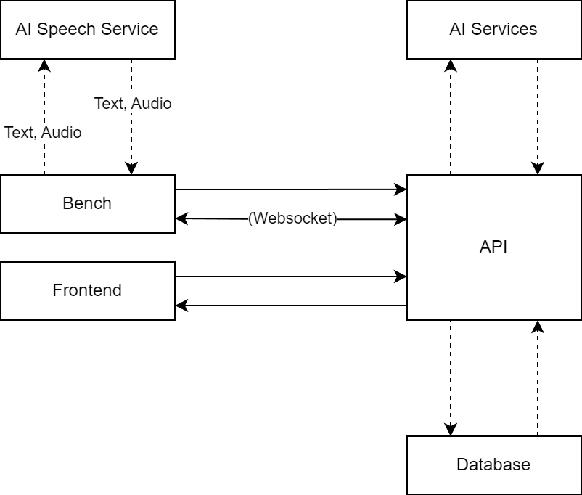

Hardware Solutions
In this part we will discuss which hardware solutions we researched, what the result of our research is and the reasoning behind our decisions.

Research
We have researched 3 different hardware solutions for the bench, and their possibilities.
Raspberry Pi
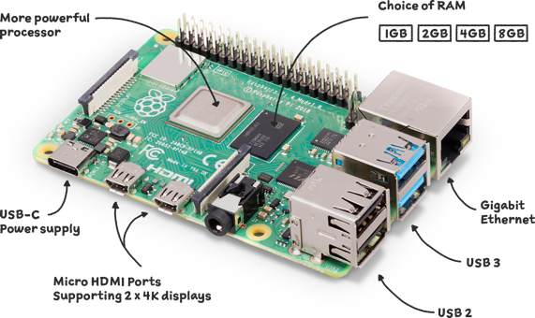
The functionalities of the Raspberry Pi are as follows. Firstly, the microphone records audio as soon as a question is asked. The speech recognition records the audio and is sent to the cloud to convert speech to text. Next, the cloud environment processes the question, finds the answer and sends it back to the Raspberry Pi. Lastly, the response can be spoken through a speaker.
Microphone
We will be using a USB microphone or 3.5mm microphone. We need to assess the microphone’s sensitivity in an outdoor environment and evaluate how well background noise is filtered. We also need to check for compatibility with the Raspberry Pi and the audio recording process.
Audio module
Here we researched 3 possible solutions.
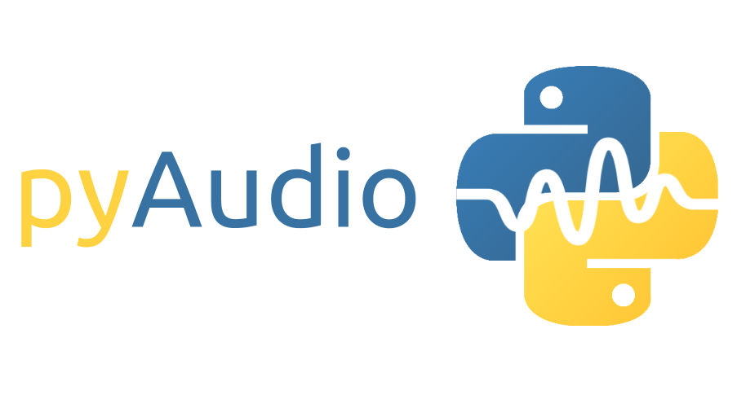
First, there’s PyAudio. It is suitable for real-time audio applications such as recording and playback. It supports multiple audio formats and sample rates, and it has a simple API and is well documented, but its dependence on PortAudio it can cause installation problems, especially on Windows.

The next option is Wave. It is a standard Python module, simple for basic use such as reading and writing WAV files. But there is no support for complex audio tasks or real-time audio.
Lastly, we did research on Audiorecorder. It is ideal for recording audio, but is very limited in functionality and not flexible for more complex applications.

SME Talk
During the meeting, Filip discussed how we can run the model locally on the microcontroller, so that it can perform calculations independently and respond directly. This minimizes the dependency on a network connection and significantly reduces the required bandwidth. The concept is that we first train the model on our server and then upload the trained version to the microcontroller.
A minimalist hardware setup was deliberately chosen: no display, only a speech module and the microcontroller itself. This fits the usage scenario, where only audio input and output are needed. A possible example that was mentioned is performing a speech-to-text conversion locally, where only necessary data is sent for further processing.
We explicitly emphasized that GDPR compliance must be a priority. This means that the microcontroller must not store any personal data, such as names and addresses. It is important to remain vigilant on this point during all development phases to prevent risks.

Conclusion
We choose for PyAudio. It is the best choice for applications that require real-time audio recording and playback. It offers a good balance between functionality and simplicity, with support for various audio formats. Although there may be some installation issues, it is the better and easier option for this project that includes speech recognition, live audio recording or audio streaming.

Final conclusion….
The goal of our project is to achieve a balance between innovation, cost-efficiency, and scalability. The following recommendations were finalized based on our research and SME consultations:
Frontend and Backend Technologies
Angular and C# were selected to ensure robust and unified development, leveraging their strengths in scalability and performance.
AI Solutions
Whisper by OpenAI, BERTje, and GoEmotions were chosen for their superior capabilities in speech and emotion recognition tailored to Dutch users.
Cloud and Database
MongoDB and modular cloud-hosted components, including Qdrant for vector database management, were recommended for their flexibility and scalability.
Hardware
Raspberry Pi with PyAudio provides a streamlined, cost-effective platform for speech-based interactions.
These choices fulfill the project's objectives by addressing critical risks, ensuring GDPR compliance, and promoting seamless user experiences. They also align with the initial project plan by delivering a clear roadmap for the realization phase. Team Benchmark remains committed to delivering a final product that meets stakeholder expectations while demonstrating technical excellence.

